
Front End (React JS)

Objective: To develop an application that manages trainee registration for various clubs and streamlines the registration tracking process within the CMC establishment, utilizing React.js and Redux Toolkit.

Question 1
- Create "Login.js", which represents the login page for the web application developed using React and Redux Toolkit.
- Users are prompted to enter their Name and their CEF (likely serving as a password) to log in.
- The page communicates with a simulated database (db.json) to validate the users' credentials.
Db.json : {
"users": [
{ "name": "farah", "cef": "123" },
{ "name": "ahmed", "cef": "456" },
{ "name": "imane", "cef": "456" }
]

- "In case of success, the user is redirected to the '/clubs' page. In case of failure, an appropriate alert is displayed to inform the user of the error. "
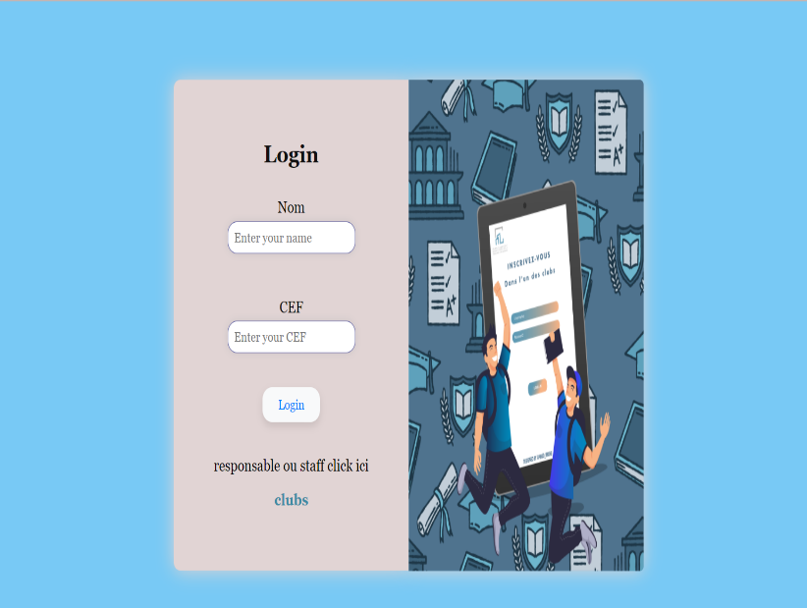 | 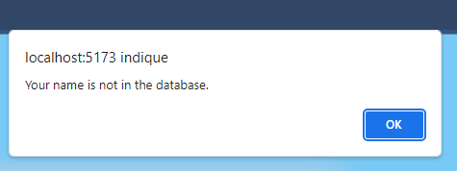

Question 2
• Create the necessary page to generate three cards with their descriptions.
• Include a function that calculates the total number of registrations.
• Note: This function should only trigger when clicking the button located on the Form page.
• The 'Inscrire' (Register) button should redirect the user to the Form page



Question 3
- Create a Form Page using React and Redux for state management.
- The page should allow users to input the following information: (Name, Email, Phone, Major/Filière, Group).
- Use Redux to store this information in the store.
- Implement a Form Reset function to clear the fields.
- Complete the code for formSlice.jsx
// formSlice.js
import { createSlice } from '@reduxjs/toolkit';
const initialState = {
nom:...,
email: ...
telephone: ...,
filiere: ...,
groupe: ...,};
const formSlice = createSlice({
name: 'form',
initialState,
reducers: {
updateField: (…., …..) => {
const { field, value } = .........;
state[field] = value;
},
resetForm: (state) => .....,
},
});
export const { updateField, resetForm } = formSlice.actions;
export const selectFormData = (state) => state.form;
export default formSlice.reducer;

• Registration Logic: The form must be accompanied by three buttons, each representing a different "club." When a user completes the form and clicks one of the buttons, the entered information must be saved in the Redux store with a key corresponding to the selected club.
• Data Flow: After registration and data storage, the information must be sent to a component that contains separate tables for each club.
Question 4
(Admin Access): Add a section for administrators to view which trainees are assigned to which club, using a password-protected admin page.
Note: All data is retrieved from the records submitted through the form page.
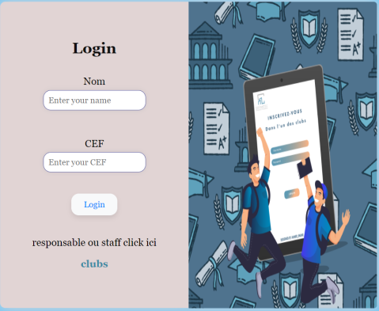 | 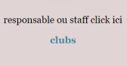 | 